**Classroom Session: Using Query Parameters to Filter Description and Short Description, Displaying 15 Records in Get All Incidents**

**Learning Objective:** The objective of this session is to learn how to use query parameters in ServiceNow API to filter incidents based on description and short_description, and to limit the results to 15 records using Postman.

**Expected Completion Time:**

* Best Case: 25 minutes
* Average Case: 35 minutes

**ServiceNow API Credentials:**

1. **Obtain Your ServiceNow Instance Credentials:**
   * Instance URL
   * Username
   * Password

**Using Query Parameters to Filter Incidents:**

**Step 1: Create a New Request**

* Click on "New" and select "HTTP Request".
* Name your request appropriately, e.g., "Filter Incidents".

**Step 2: Set Up the Request URL**

* Set the request type to GET.
* Enter the ServiceNow API endpoint for retrieving incidents:

**GET** https://<your_instance>.service-now.com/api/now/table/incident

* Replace <your_instance> with your ServiceNow instance name.

**Step 3: Set Query Parameters**

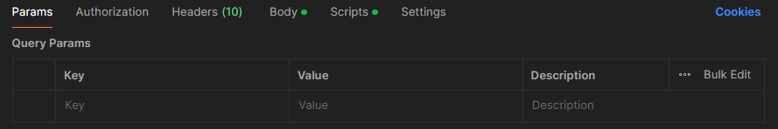

* Click on the "Params" tab.
* Add the following query parameters:
  + sysparm_query:
  + **Key - description**  <your_description_value>
  + **Key - short_description** <your_short_description_value>
  + **Key - sysparm_limit**: **value**-**15**

**Step 4: Authentication**

* Go to the "Authorization" tab.
* Select "Basic Auth".
* Enter your ServiceNow Username and Password.

**Step 5: Send the Request**

* Click "Send".
* Observe the response in the lower pane. Ensure it contains the filtered list of incidents.

**Step 6: Validate Response**

* Verify the response contains up to 15 records and matches the filter criteria.

**Step 7: Optional: Automate Validation Using Tests**

* Go to the "**Scripts**" tab and add the following script to validate the response:

pm.test("Status code is 200", function () {

  pm.response.to.have.status(200);

});

pm.test("Response contains 15 or fewer records", function () {

  var jsonData = pm.response.json();

  pm.expect(jsonData.result.length).to.be.at.most(15);

});

**Expected Outcome:**

Upon completion, you should be able to:

* Understand how to use query parameters in ServiceNow APIs.
* Filter incidents based on description and short_description.
* Limit the results to 15 records.
* Validate the response to ensure it meets the criteria and displays the expected number of records.